Luxembourg Development Indicators Analysis
Done by Tudor Sclifos, IS-251M

1. Introduction
Luxembourg, a small yet economically significant nation in Western Europe, serves as an intriguing case study for development economics. This analysis examines Luxembourg's development patterns over the past 20-30 years through three key research questions:
- How has the relationship between inflation and unemployment evolved over the past 20 years?
- How does population life expectancy relate to GDP per capita growth?
- How do unemployment rates correlate with emigration patterns?

2. Data and Methods

2.1 Data Source and Indicators
All data were obtained from Eurostat, covering 14 indicators across economic (inflation, GDP, consumption, trade), labor market (unemployment), and demographic (population, migration, life expectancy, deaths) categories. Job vacancies and house prices were excluded due to insufficient historical data.
Category | Key Indicators
Economic | Inflation, GDP, Consumption, Exports, Imports, Current Account
Labor | Unemployment Rate
Demographic | Population, Emigration, Immigration, Life Expectancy, Deaths

2.2 Methodology
Data cleaning included standardizing time formats, detecting outliers using IQR method (all retained as genuine events), and temporal alignment. Variables were z-score normalized for visual comparison. Analysis employed univariate (distributions, descriptive statistics), bivariate (correlations, time series), and temporal pattern examination techniques.

3. Results

3.1 Research Question 1: Inflation-Unemployment Relationship
Analysis of 2004-2024 reveals a negative correlation between inflation and unemployment, consistent with Phillips Curve theory, though the relationship varies significantly over time. The standardized visualization below shows the relationship is stronger during normal periods but breaks down during major shocks (2008 financial crisis, COVID-19).
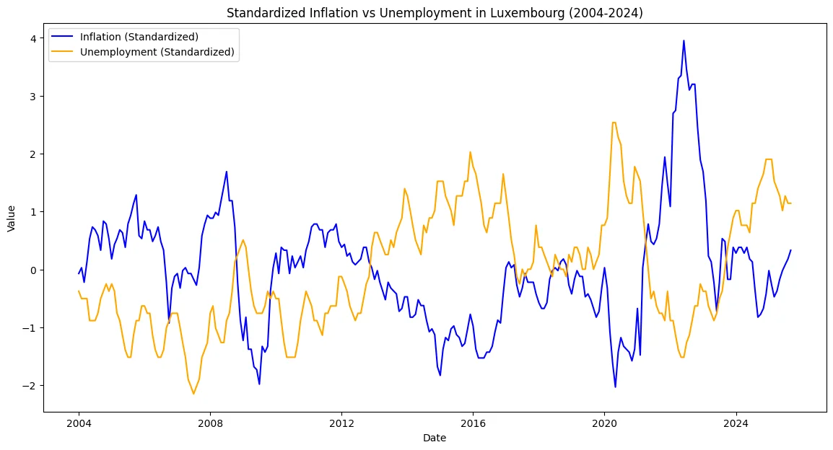
Figure 1: Standardized Inflation vs Unemployment in Luxembourg (2004-2024)

3.2 Research Question 2: Life Expectancy and Economic Prosperity
A remarkably strong positive correlation (r = 0.95) exists between life expectancy and GDP per capita from 1994-2024. Both variables show consistent upward trends, demonstrating that economic prosperity directly enables healthcare improvements and better living standards.
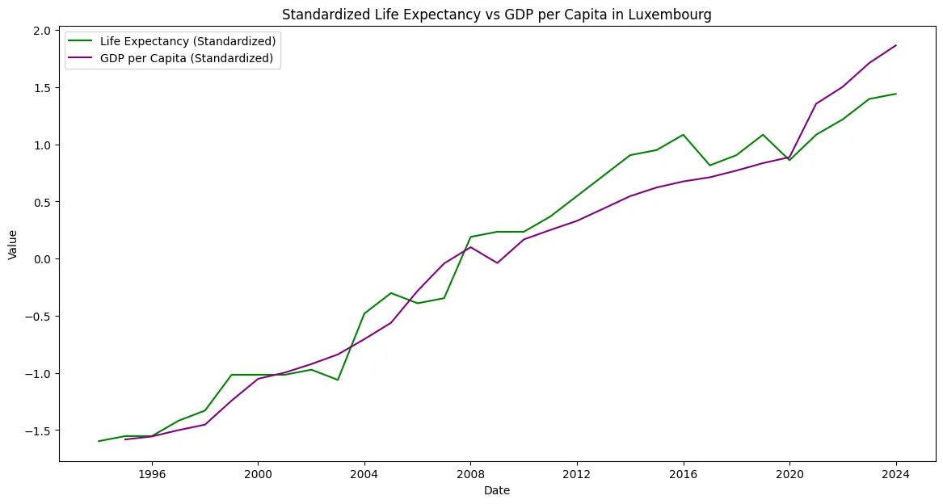
Figure 2: Standardized Life Expectancy vs GDP per Capita in Luxembourg

3.3 Research Question 3: Unemployment and Emigration
After controlling population growth effects, a negative correlation emerges between unemployment and emigration—contradicting conventional theory that unemployment drives emigration. Between 2010-2016, no visible correlation exists, suggesting effective population management. The inverted relationship may reflect Luxembourg's unique position: during downturns, fewer people emigrate because alternative destinations face similar conditions.
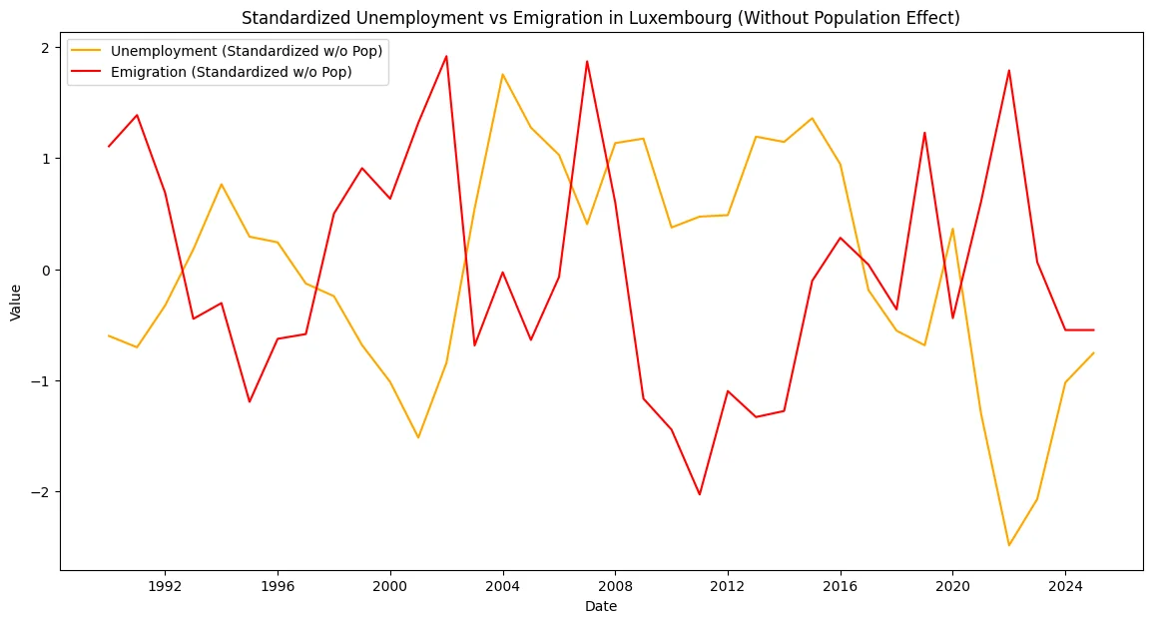
Figure 3: Standardized Unemployment vs Emigration (Without Population Effect)

3.4 Correlation Analysis
To better understand the relationships between indicators, both Pearson and Spearman correlation analyses were conducted. The correlation heatmaps below reveal several significant relationships beyond the three research questions.
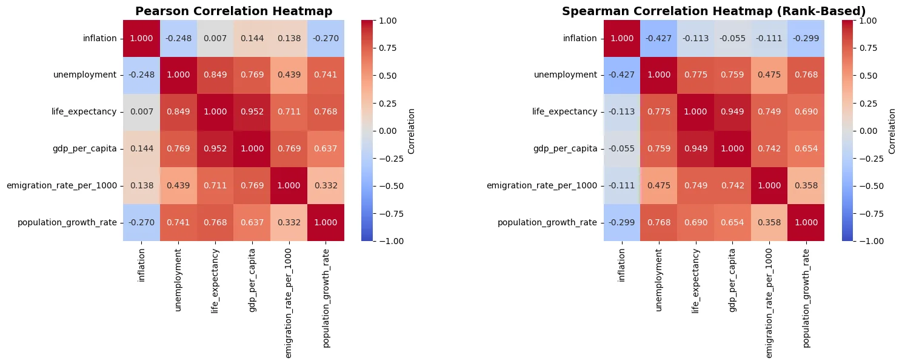
Figure 4: Pearson and Spearman Correlation Heatmaps
The correlation analysis reveals several key patterns. Strong positive correlations exist between life expectancy and GDP per capita (r = 0.95), unemployment and life expectancy (r = 0.85), and unemployment and GDP per capita (r = 0.77). These relationships are consistent across both Pearson and Spearman methods, indicating robust linear and monotonic relationships.
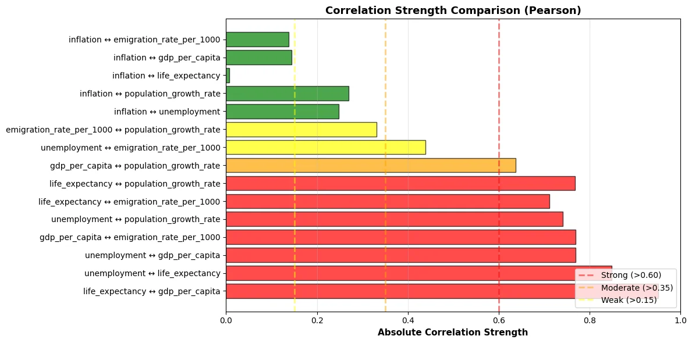
Figure 5: Correlation Strength Comparison (Pearson)
The ranked correlation strength chart highlights the most significant relationships. Notably, the strongest correlations (above 0.80) include life expectancy with GDP per capita, unemployment with life expectancy and GDP per capita, and various indicators with population growth rate. Weaker correlations (green bars) involve inflation, which shows relatively independent behavior from other indicators.

3.5 Key Univariate Findings
- Inflation: Well-anchored around 2.3%, ranging from -1.6% to 10.3% (COVID spike). Stable target-tracking regime with crisis disruptions.
- GDP Growth: Approximately 6-fold increase (3,781 to 22,941 million EUR). Near-normal distribution indicates stable, predictable expansion.
- Unemployment: Bimodal distribution with peaks at 2-3% (tight market) and 5-7% (crisis), suggesting two distinct labor market regimes.
- Demographics: Population grew 2.14-fold. Immigration (17,000/year) far exceeds emigration (10,000/year), driving growth.
- Life Expectancy: Stable at ~77 years with steady incremental improvements, demonstrating healthcare system resilience.

4. Discussion

4.1 Key Implications
Luxembourg's development model successfully translates economic growth into improved quality of life, evidenced by the exceptionally strong life expectancy-GDP correlation (r = 0.95). However, several concerns emerge from the correlation analysis. The positive correlation between GDP per capita and unemployment (r = 0.77) suggests 'jobless growth'—productivity gains not fully converting to employment. This pattern implies economic expansion driven by capital intensity and automation rather than labor absorption.
The positive GDP-emigration link (r = 0.77, based on per capita emigration rates) indicates potential brain drain during prosperity periods. Wealthier individuals possess greater resources for international mobility, creating a counterintuitive dynamic where economic success facilitates human capital outflow. The weak correlations between inflation and most other indicators (-0.27 to 0.14) suggest that inflation operates relatively independently, likely driven by external factors rather than domestic economic conditions—consistent with Luxembourg's position as a small, open economy highly integrated into European markets.
The strong positive correlation between unemployment and life expectancy (r = 0.85) initially appears paradoxical but reflects healthcare system resilience and the temporal alignment of both variables with long-term development trends. Life expectancy improvements continue even during economic downturns because Luxembourg maintains healthcare investments during crises, demonstrating the value of counter-cyclical social spending.

4.2 Limitations
- Data Coverage: Insufficient historical data for job vacancies and housing prices limited comprehensive labor/housing analysis.
- Causality: All findings are correlational; causal mechanisms require econometric modeling with appropriate controls.
- Omitted Variables: Education quality, technology, policy interventions not directly measured but likely influential.
- Generalizability: Luxembourg's unique characteristics (financial center, small size, high immigration) limit broader applicability.

4.3 Future Research
Future studies should employ causal analysis techniques (VAR, Granger causality), formal structural break testing around crisis periods, sectoral decomposition to understand differential impacts, distributional analysis examining inequality trends, comparative studies with similar small economies (Switzerland, Netherlands), and incorporation of quality-of-life indicators beyond GDP. Particular attention should be paid to the mechanisms behind jobless growth and strategies to ensure prosperity translates into employment opportunities.

5. Conclusion
This analysis reveals Luxembourg as a nation achieving exceptional economic growth while maintaining strong social outcomes. The three research questions yielded important insights: inflation-unemployment relationships exist but vary temporally; economic prosperity strongly correlates with health improvements (r = 0.95); and unemployment-emigration patterns defy conventional theory, reflecting Luxembourg's unique economic position.
The comprehensive correlation analysis uncovered additional critical relationships. Most notably, the positive correlations between GDP per capita and both unemployment (r = 0.77) and emigration rate (r = 0.77) raise sustainability concerns about Luxembourg's growth model. These patterns suggest economic expansion may not be creating sufficient employment opportunities and could be facilitating human capital outflow—two challenges that warrant immediate policy attention.
Key findings include remarkable GDP growth (6-fold increase), bimodal unemployment distribution suggesting distinct economic regimes, population growth driven by immigration exceeding emigration, and resilient life expectancy improvements even during crises. The weak correlations between inflation and other indicators (-0.27 to 0.14) confirm that inflation in Luxembourg is primarily driven by external factors rather than domestic conditions.
Luxembourg demonstrates that small economies can thrive globally by leveraging strategic advantages, but sustainability requires addressing employment quality, managing demographic pressures from high immigration, and ensuring growth translates into broadly shared prosperity. The visualization of correlation strengths provides clear priorities for policymakers: strengthening the employment-growth link, managing emigration of skilled workers, and maintaining the proven connection between economic prosperity and health outcomes.
While this exploratory analysis has limitations in establishing causality, it provides a robust empirical foundation through multiple analytical lenses—time series patterns, bivariate relationships, and comprehensive correlation matrices. The patterns identified provide benchmarks for future evaluation and evidence for policy design, particularly around the productivity-employment disconnect and the complex interplay between prosperity, migration, and labor markets in small, open economies.

Appendix: Indicator Specifications
Economic Indicators
Indicator | Code | Frequency | Unit
Inflation (HICP) | ei_cphi_m | Monthly | Rate (t/t-12)
GDP | namq_10_gdp | Quarterly | Million EUR
Final Consumption | nasa_10_nf_tr | Annual | Million EUR
Exports | namq_10_exi | Quarterly | Million EUR
Imports | namq_10_exi | Quarterly | Million EUR
Current Account | tipsbp40 | Quarterly | Million EUR
Labor Market Indicators
Indicator | Code | Frequency | Unit
Unemployment Rate | une_rt_m | Monthly | Percentage (%)
Job Vacancies* | jvs_q_nace2 | Quarterly | Count
Demographic Indicators
Indicator | Code | Frequency | Unit
Population | demo_pjangroup | Annual | Persons
Emigration | migr_emi2 | Annual | Persons
Immigration | migr_imm8 | Annual | Persons
Life Expectancy | demo_mlexpec | Annual | Years
Deaths | demo_gind | Annual | Count
Housing Market Indicator
Indicator | Code | Frequency | Unit
House Price Index* | prc_hpi_q | Quarterly | Index (2010=100)
* Indicators excluded from final analysis due to insufficient historical data for Luxembourg (< 20 years)

